Regulations:
A14

H.T No

Sreenidhi Institute of Science and Technology
(An Autonomous Institution)
Code No: 4F302 Date: 18-June-2019 (AN)

B.Tech II-Year I-Semester External Examination, June-2019 (Supplementary)
Mathematical Foundations of Computer Science (CSE and IT)

Time: 3 Hours Max.Marks:70

Note: a) No additional answer sheets will be provided.
b) All sub-parts of a question must be answered at one place only, otherwise it will not be valued.
c) Missing data can be assumed suitably.

Part - A Max.Marks:20

Answer all QUESTIONS.

1. | Using the statements:  R: John is Healthy  H: John is clever  Write the following statements in symbolic form.  i) If John is healthy the he is not clever. (ii) John is not healthy but clever. | [2M]
2. | Prove that in a lattice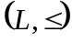, 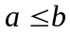 if and only if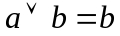. | [2M]
3. | Express 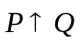in terms of (NOR) only. | [2M]
4. | Prove that 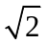 is an irrational number by contradiction. | [2M]
5. | Construct the truth table for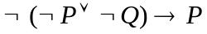. | [2M]
6. | Is there a graph with degree sequence (1,2,3, 4, 5, 6, 7)? Give reasons. | [2M]
7. | Enumerate the number of non negative integral solutions to the equation.  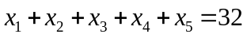 | [2M]
8. | In a connected simple planar graph show that |E| ≤3|V|-6. | [2M]
9. | Draw all non isomorphic posets on a set with three elements. | [2M]
10. | What are Hamiltonian graphs? | [2M]
Part – B Max.Marks:50
ANSWER ANY FIVE QUESTIONS. EACH QUESTION CARRIES 10 MARKS.

11. | a) | Show that is a tautology. | [5M]
 | b) | Prove that 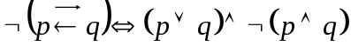 | [5M]
12. | a) | If is the relation on the set Z of integers defined by 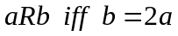and if  S={(c, d) Z x Z / d = 3c}, find ,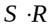 | [5M]
 | b) | Show that from the  conclusion 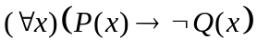 follows. | [5M]
13. | a) | Draw the Hasse diagram for the poset ( I₃₆, / ) draw a poset diagram and determine all maximal and minimal elements where I₃₆ denotes the set of all divisors of 36 and / is divisibility relation. | [5M]
 | b) | Suppose that R is an arbitrary transitive reflexive relation on a set A. Prove that the relation E defined by 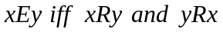 is an equivalence relation | [5M]
14. | a) | Show that in a group <G,*>, for all a, b in G, show that then G must be abelian | [5M]
 | b) | Find the left cosets of {[0],[3]} in the group <Z₆, +₆> | [5M]
15. | a) | Define an Eulerian graph. Construct if possible, an Euler graph with 6 vertices and 10 edges and justify your answer | [5M]
 | b) | Show that x ≡_{m} y where ≡_{m} denotes that x-y is divisible by m, is an equivalence relation and list the equivalence classes | [5M]
16. | a) | If 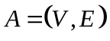is digraph then for 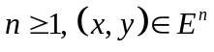 iff there is a directed path of length from 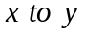 | [5M]
 | b) | "A complete bipartite graph 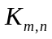 is planar iff 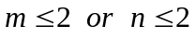". prove or disprove. | [5M]
17. | a) | Explain the concept of isomorphism of graphs with an example. | [5M]
 | b) | Show that 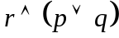 is a valid conclusion from the premises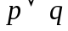,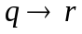,  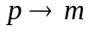 and. | [5M]
18. | a) | Find the number of numbers between 1 and 500 (both inclusive) which are divisible by 3 or 5 or 7. How many of them are divisible by 3 or 7 but not by 5. | [5M]
 | b) | How many integral solutions are there where each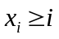. | [5M]

-- 00 -- 00 –

